**OKENIYI ESTHER**

**Changelle**

-Fibonacci

-Fizzbuzz

-Combination

-Cooking Rice

-Shopping

**FIBONACCI**

PESUDOCODE:

1. Start
2. Declare variable a, b, c, n,i
3. Initialize Variable a=0, b=1 and i=2
4. Read n from user
5. Print a and b
6. Repeat until i<n

Step 6.1 : c=a+b

Step 6.2: Print c

Step 6.3: a=b, b=c

Step 6.4: I=i+1

1. Stop

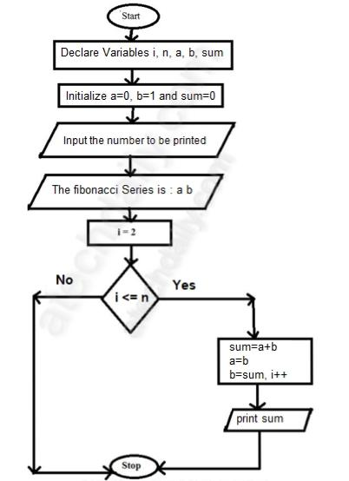FLOWCHART FOR FIBONACCI

**FIZZBUZZ**

PESUDOCODE

1. Write a program that prints the numbers from 1 to 100.
2. But for multiples of three print “Fizz” instead of the number.
3. For the multiples of five print “Buzz”
4. For numbers which are multiples of both tdhree and five print “FizzBuzz”

FLOWCHART FOR FIZZBUZZ

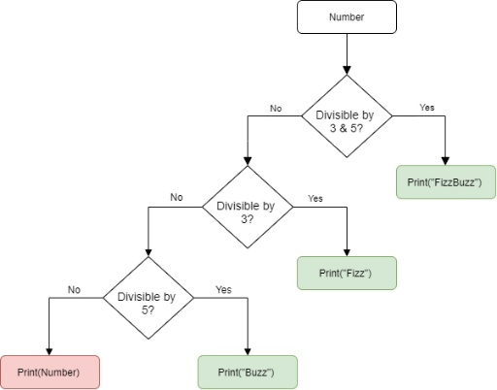

**COMBINATION**

PESUDOCODE

Fact(n)

1. Start

2. Set res=1

3. Repeat step3 and 4 until I<=n

4. res=res*1

5. Return res

6. End

**FLOWCHART FOR COMBINATION**

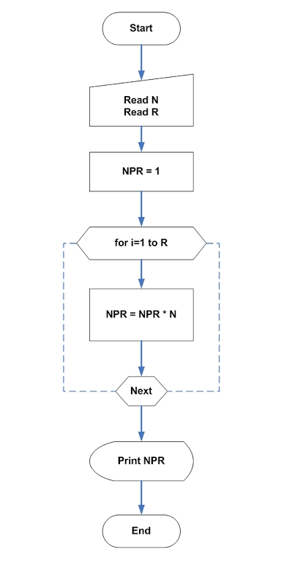

**COOKING RICE**

PESUDOCODE

1. Rinse the rice.
2. Use the right ratio of water.
3. Bring the water to a boil then a pinch of salt.
4. Reduce heat low, cover the pot with a tight cover.
5. Boil water for about 18minutes don't allow the steam to escape.
6. Then pour the rice that was rinsed inside the boil water
7. After the water is dried your rice is ready.

FLOWCHART FOR COOKING RICE

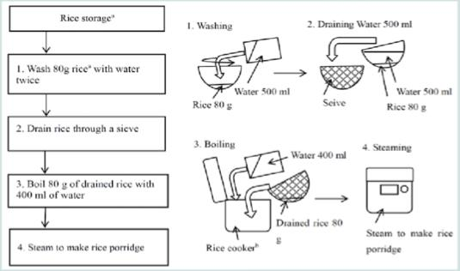

**SHOPPING (ONLINE)**

PESUDOCODE

* 1. Select a product / quantity and add it to the shopping cart.
  2. Check out, As part of check out you will have to choose or specify a shipping address and chose method of shipping. Then the system will calculate the total.
  3. Choose payment: could credit card(Visa)or PayPal.
  4. Validate payment, create an order and send an email to the purchaser.
  5. Some rules:
     + You need to log in using mail id and password before you can checkout.
     + Valid forms of payment include Visa or paypal.

FLOWCHART FOR ONLINE SHOPPING

